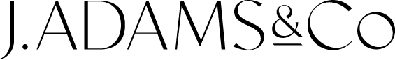

INTRODUCING THE TOR DOWN WALL LIGHT

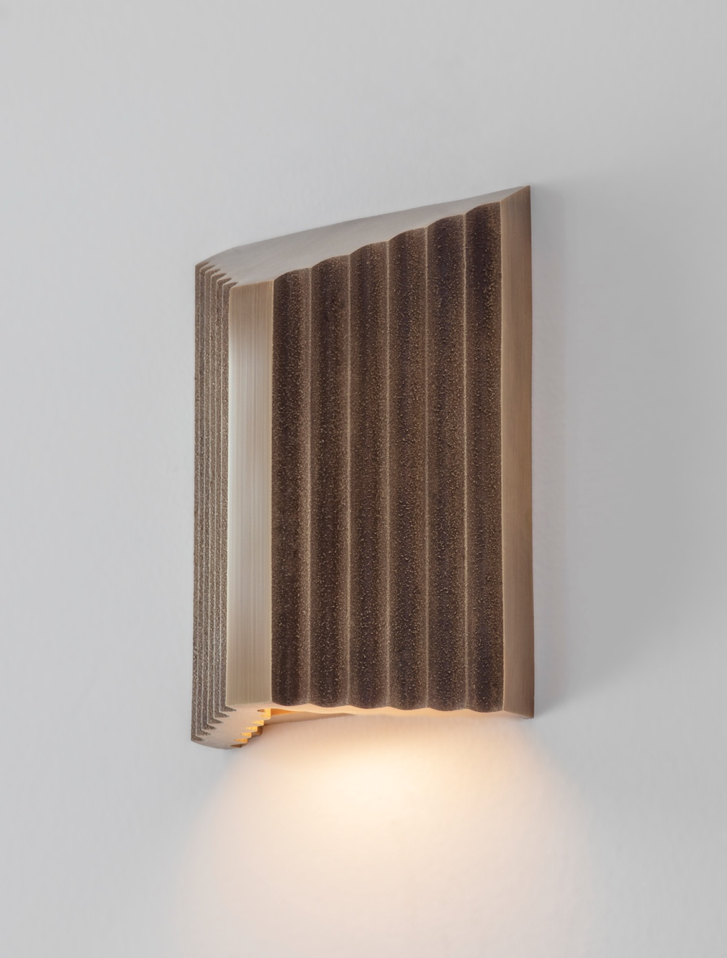

British lighting manufacturer J. Adams & Co proudly announces the launch of their latest product, the Tor Down Wall Light. This new addition complements the existing Tor Up\Down Wall Light, offering a smaller design that focuses solely on downward illumination.

Inspired by the iconic natural formations, which have long stood as symbols of enduring beauty and strength, Tor captures the essence of its namesake. Much like these grand landforms that have weathered the test of time, the Tor Wall Light is a testament to the materiality and longevity that define the brand.
A new direction for J. Adams & Co, Tor is the first collection to explore the decorative capabilities of metal casting. This centuries-old process starts by creating a mould into which molten brass is poured, taking shape as it cools. The cast pieces are then removed, refined and finished to exacting standards.

"At J. Adams & Co, we pride ourselves on blending traditional craftsmanship with innovative design, and the Tor collection is a true embodiment of that." Design Director Will Earl

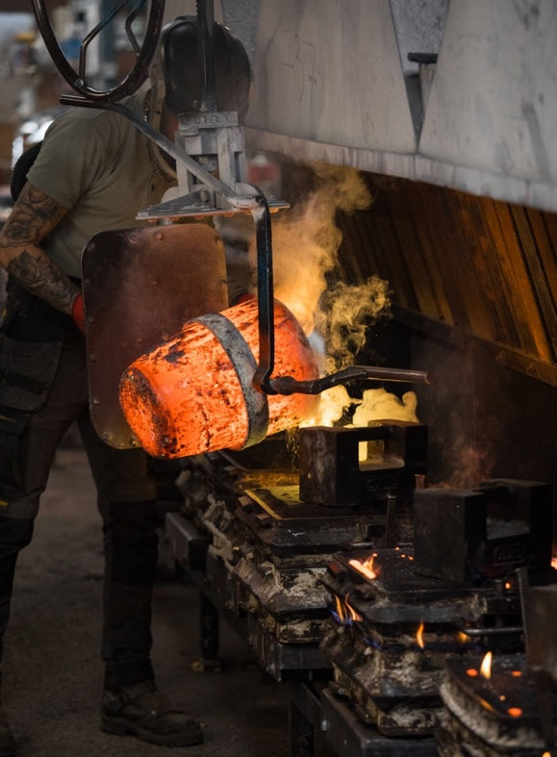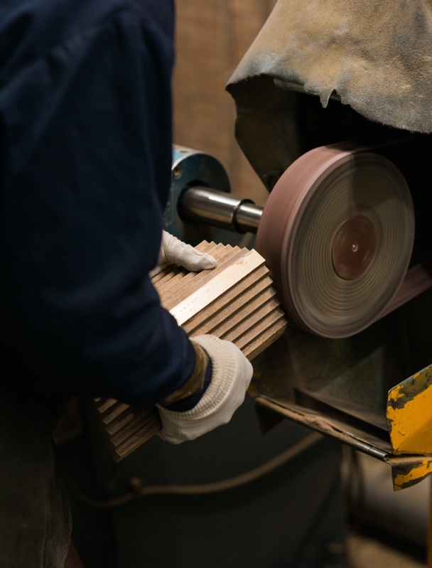

The Tor Down Wall Light casts a stunning downward illumination that is perfect for lighting pathways, steps and corridors. This version can also be used to accentuate architectural features, bringing both the wall and space to life. With an IP65-rating as standard, Tor ensures reliable long-lasting illumination that can be enjoyed both indoors and outdoors.

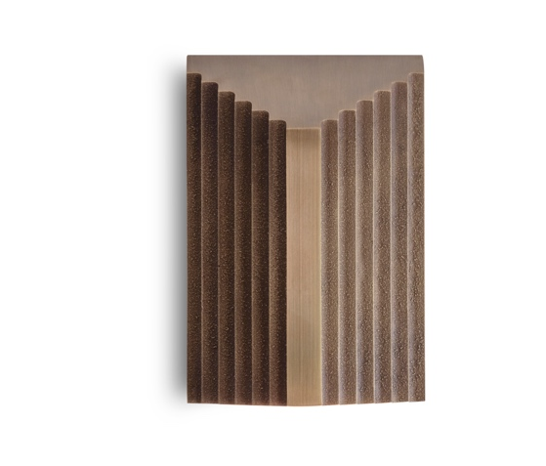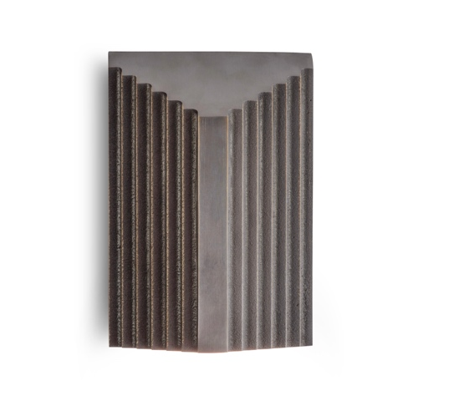

For high resolution imagery, videos, prices and product loans, please contact press@jadamsandco.com

Notes to Editors:
J. Adams & Co is a British lighting manufacturer that specialises in elegant luminaires of unparalleled quality. Handmade in the UK, their Birmingham factory has over half a century of manufacturing and metalworking expertise. The brand seamlessly melds traditional techniques with a nuanced, modern sensibility, focusing on craftsmanship and longevity. The result: refined and contemporary lighting that is built to last.



